JAT Task-12

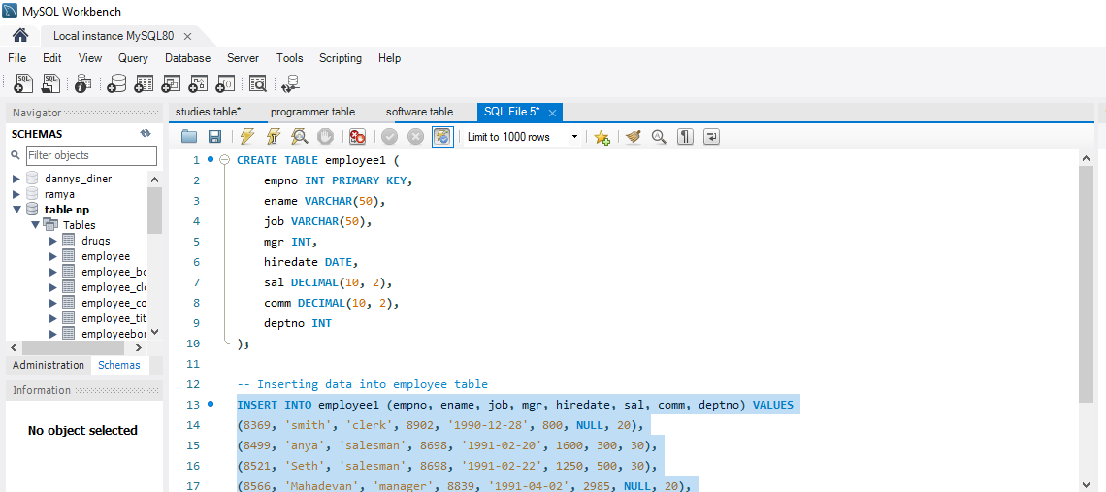

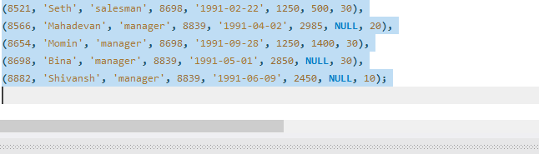

1.A. Write a query to display Ename and sal of employees whose salary are greater than or equal to 2200

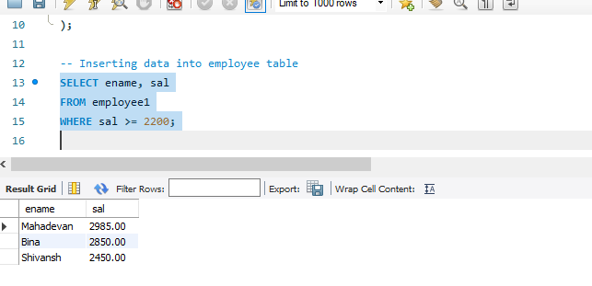

B. Write a query to display details of employees who are not getting commission

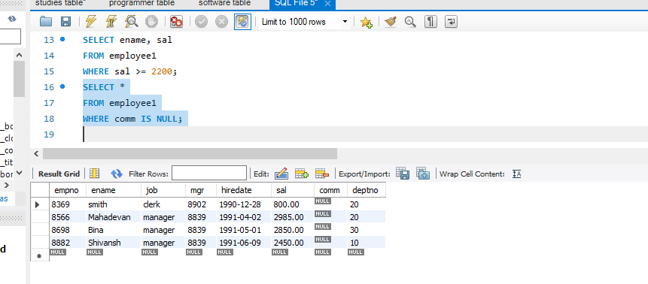

c. Write a query to display employee name and salary of those employee who don't have their salary in the range of 2500 to 4000

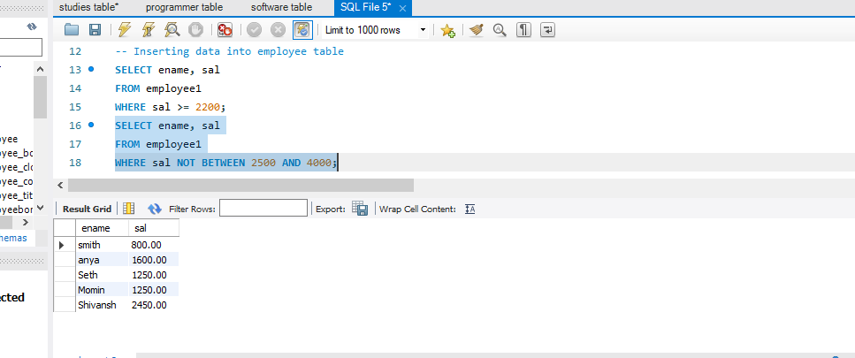

D. write a query to display the name, job title and salary of employees who don't have a manager

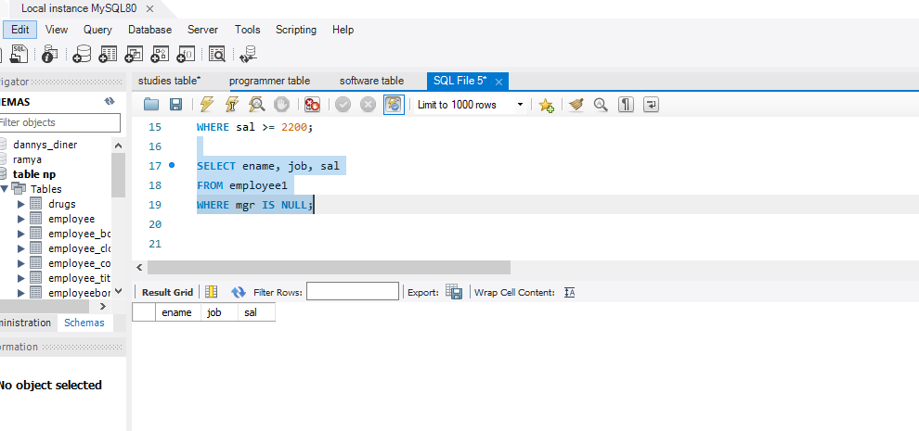

e. Write a query to display the name of an employee whose name contains"A" as third alphabet

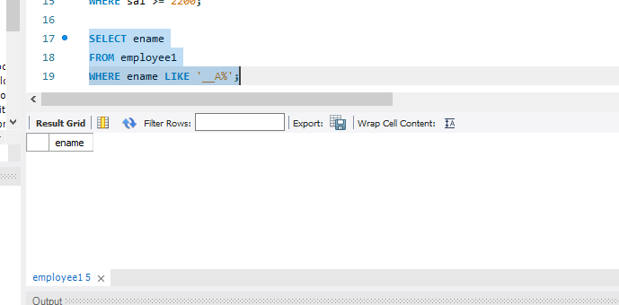

F.write a query to display the name of an employee whose name contains "T" as the last alphabet

